**DATA ANALYTICS**

STUDENT EXAM PERFORMNCE

Performing queries Students Performance in Exam

1. imports the **Pandas** library and assigns it .

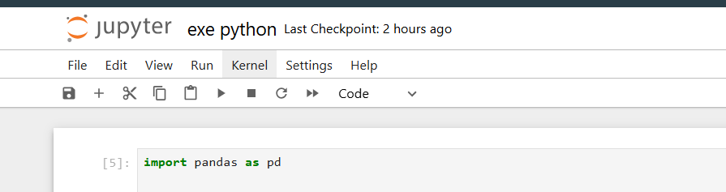

1. loads the **CSV file** into a **Pandas DataFrame** named rg for data analysis.

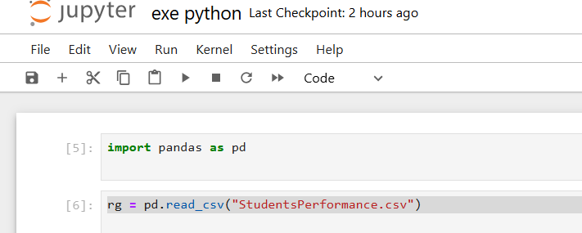

1. print(rg) displays the entire **DataFrame** rg, showing the dataset loaded from "StudentsPerformance.csv

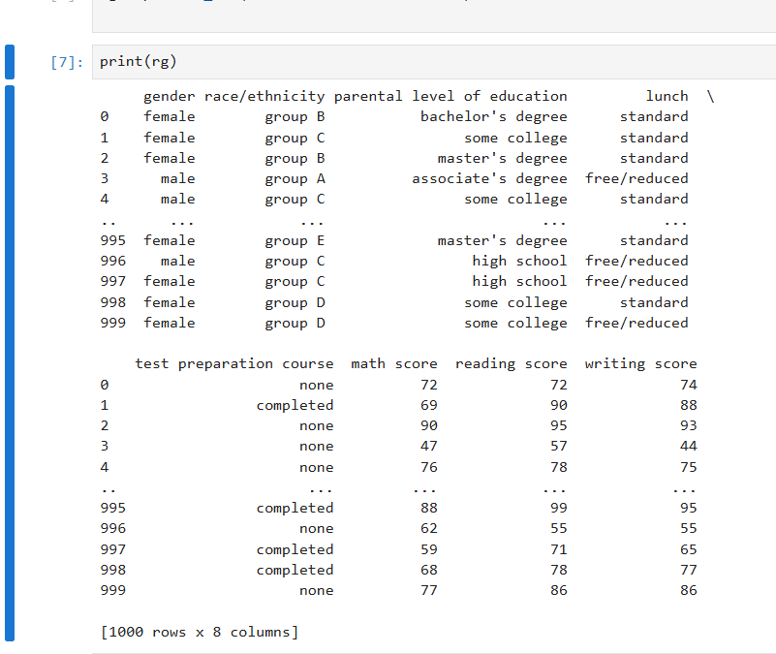

1. display the first five rows of data cell.

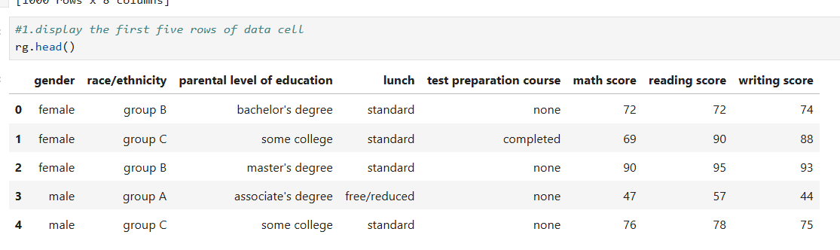

1. display the last five rows of data set.

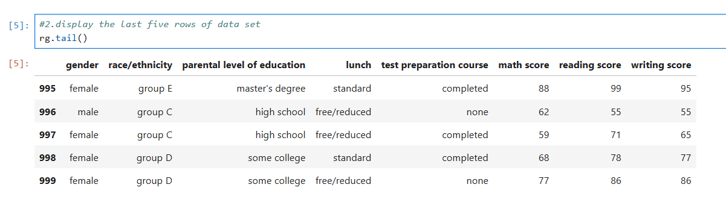

1. display the number of counts of rows and columns.

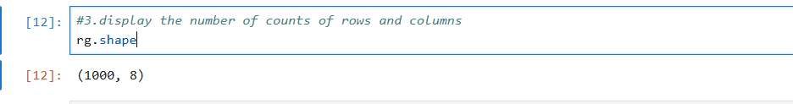

1. display summary or information about data set including data types and non null counts.

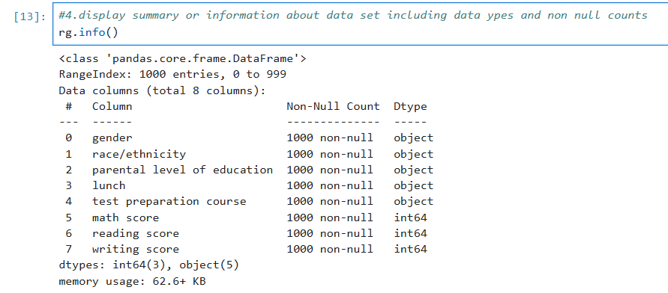

1. get descriptive statistics for numerical columns in data frame.

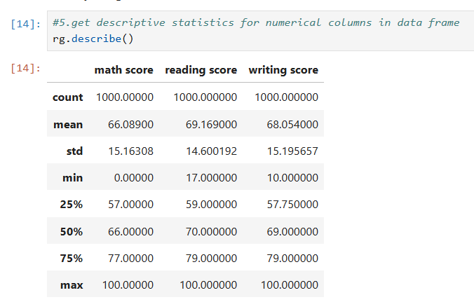

1. select the maths score column from data set.

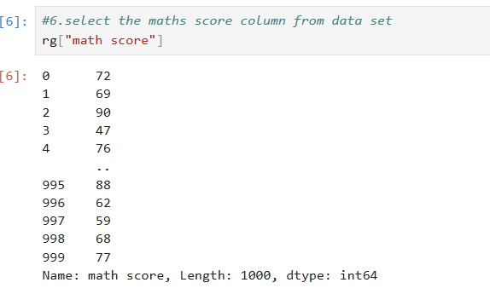

1. Selecting a specific column

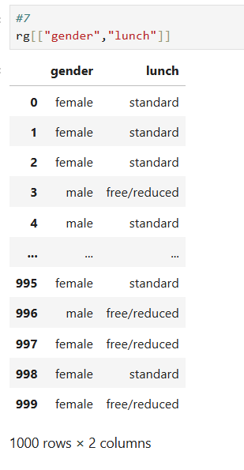

1. SELECT THE first row from the the data set by index.

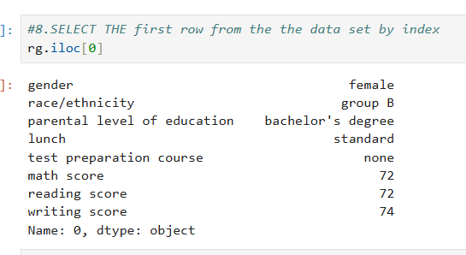

1. select the row with label index 0 from data set.

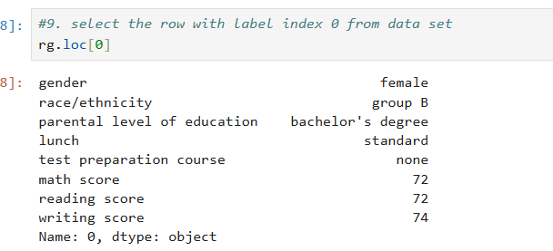

1. select rows from 1 to 4 and column from 2 to 6

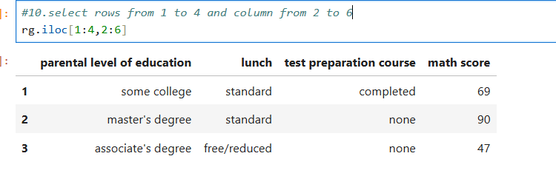

1. filter the data set for rows where math score is greater than 30(data framework method).

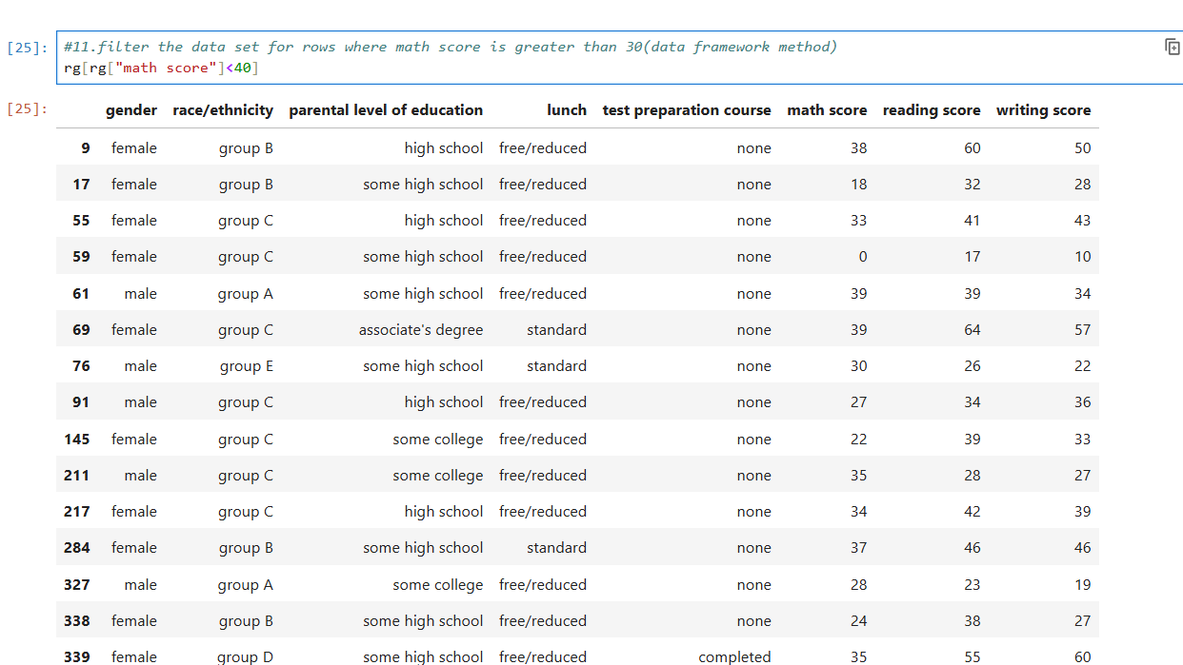

1. Performing specific condition

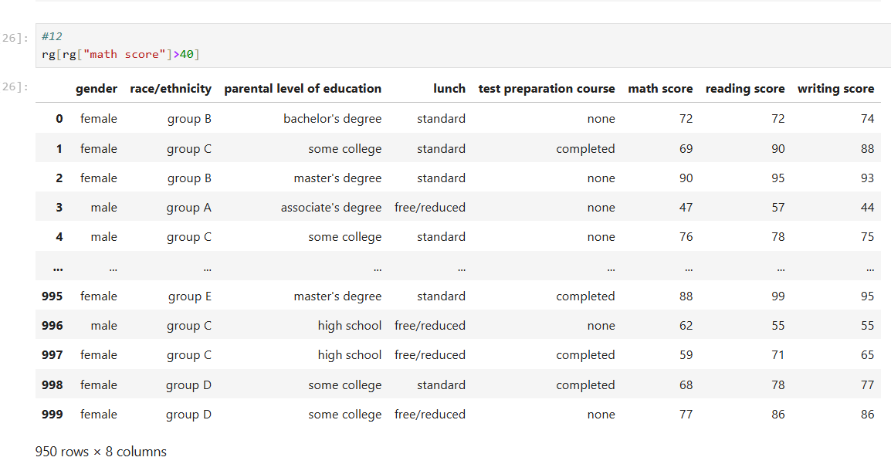

1. check if there are any missing values in data frame.

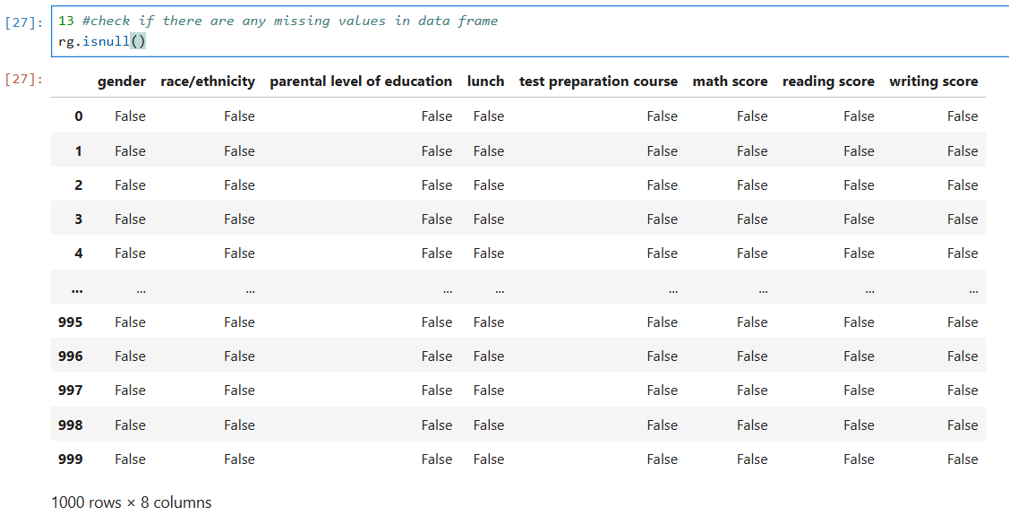

1. count the number of missing values in the dataset

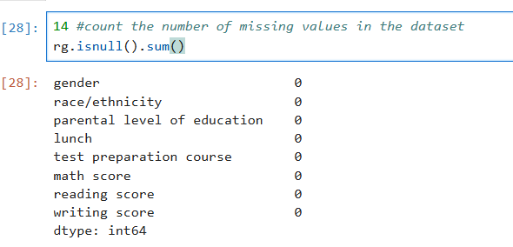

1. fill missing values with zero.

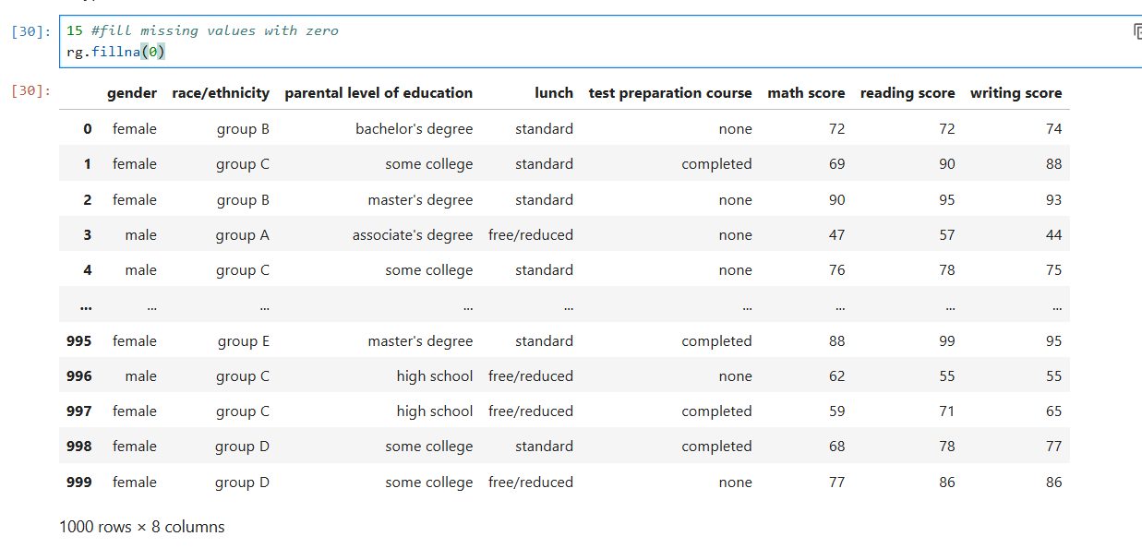

1. Checking the records.

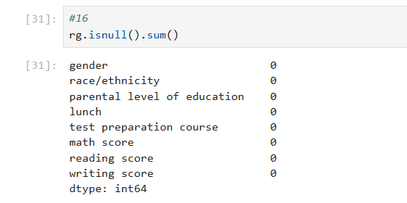

1. check the datatypes of the column

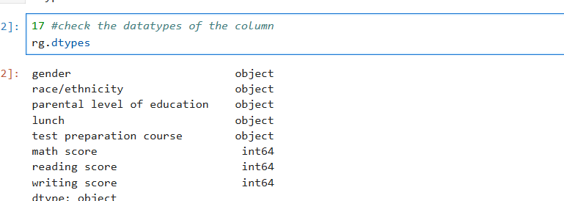

1. sort the dataset or dataframe based on specific column True=female false= male

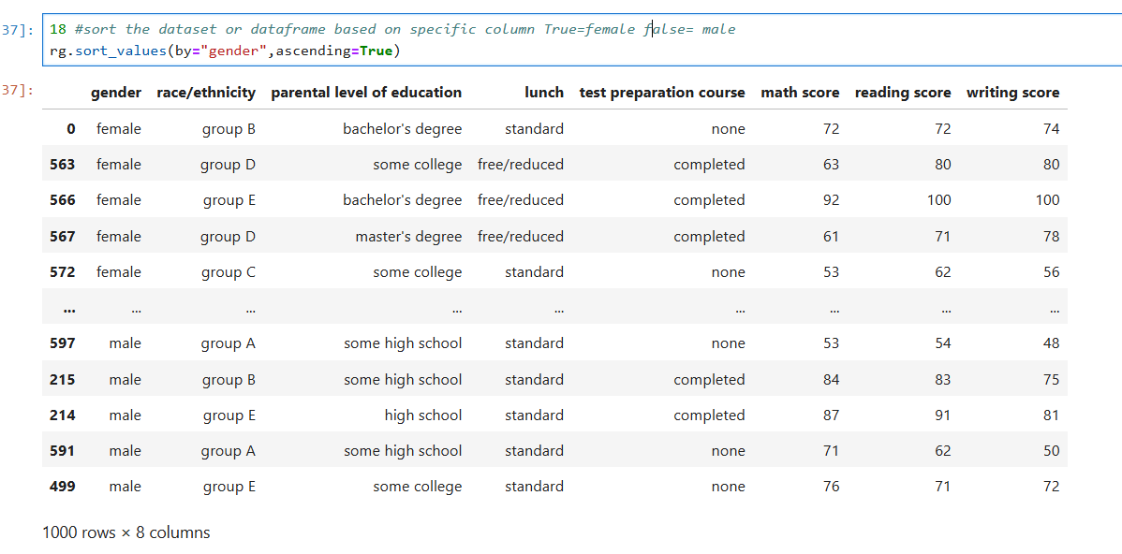

1. Shorting the data with certain conditions

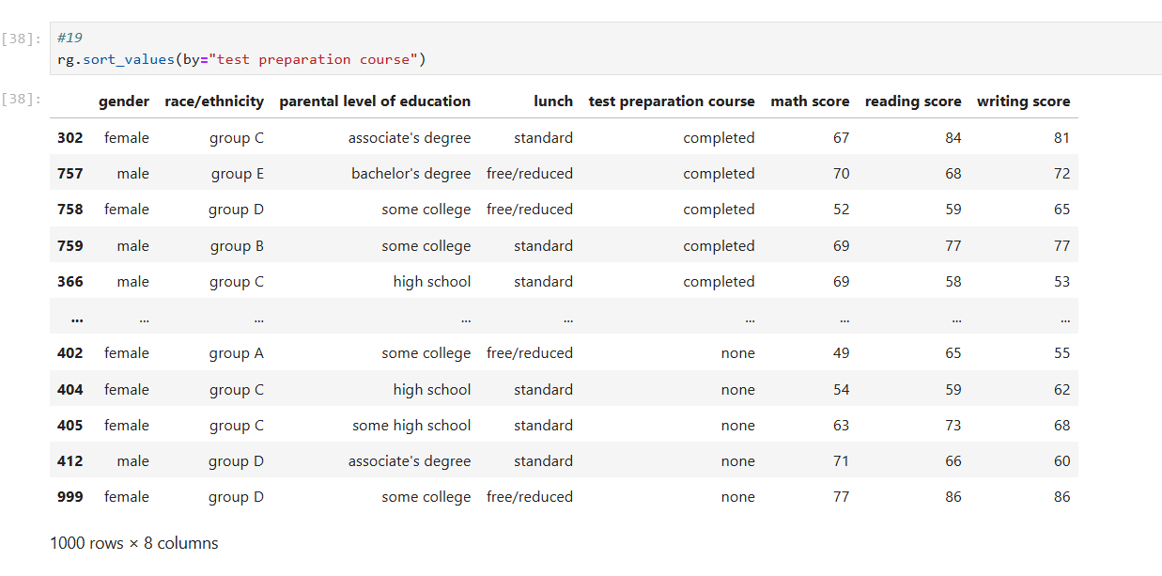

1. Sortind the data with head head

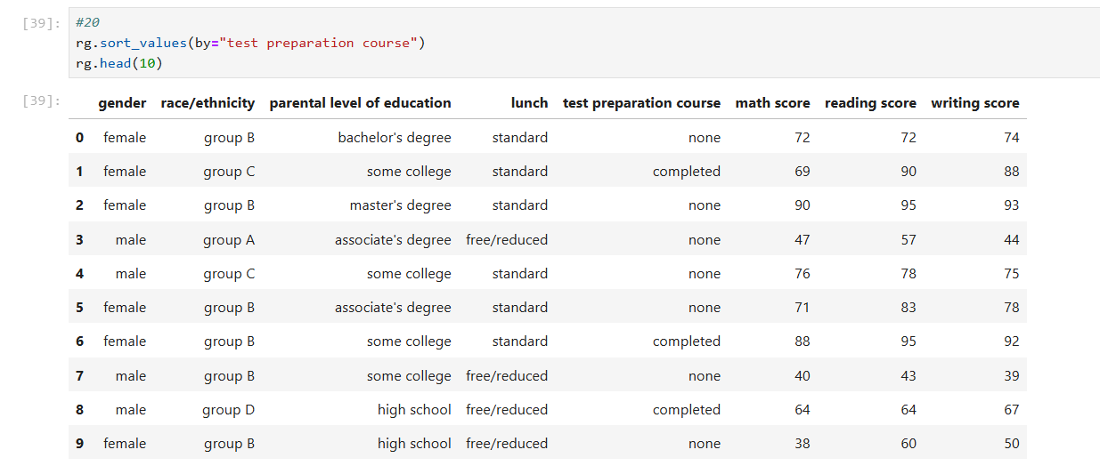

1. find minimum and maximum value of column.

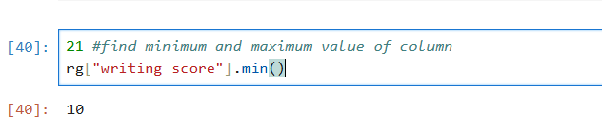

25 . maximum value of the column

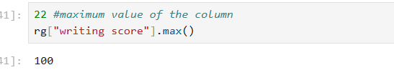

26 . unique values in the column

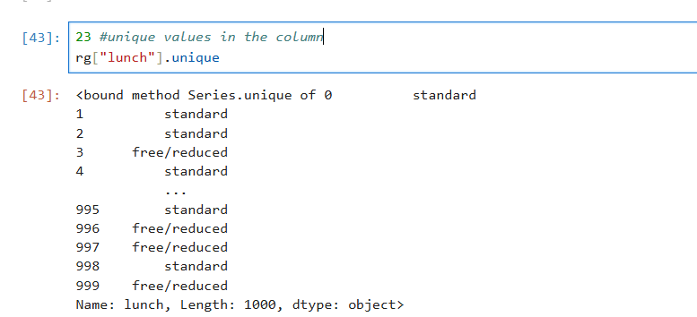

1. no of unique valus in the column

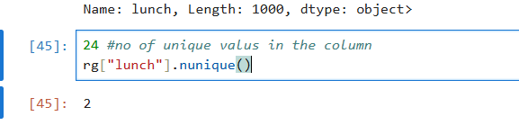

1. filter the rows where thetest preparation course has completed (data frame method)

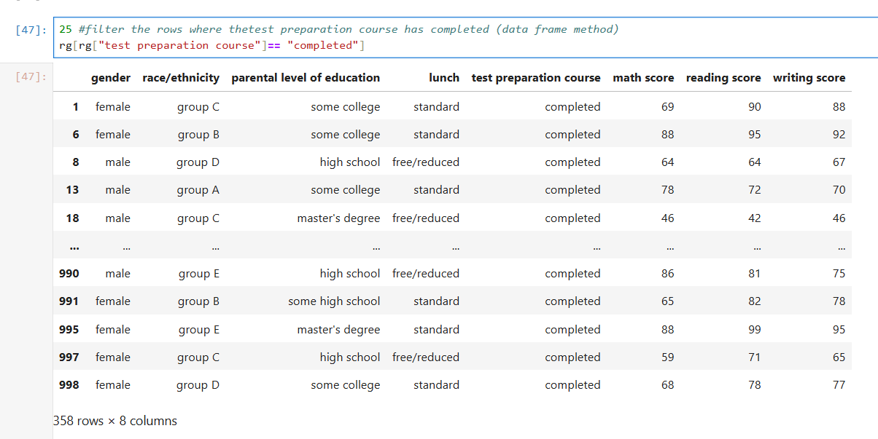

1. filter for high reading score.

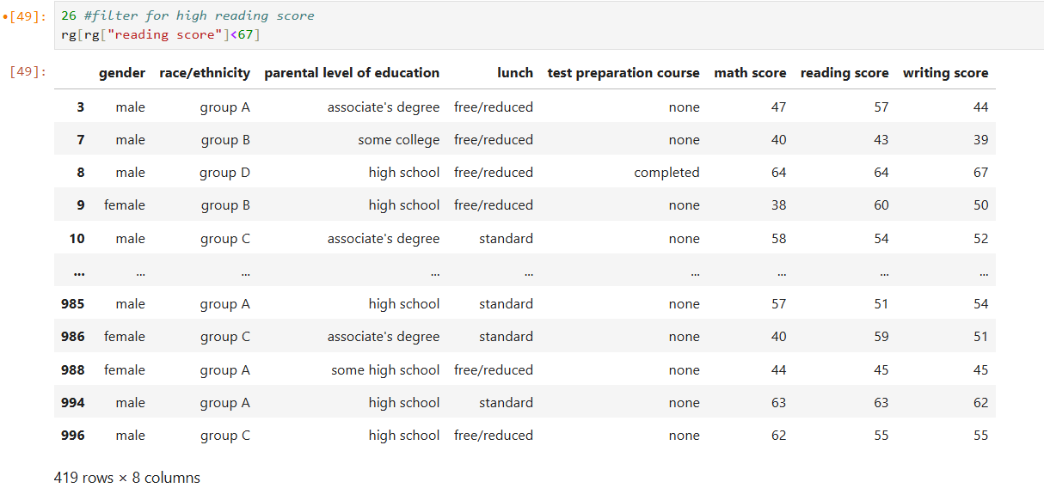

1. change he value of column

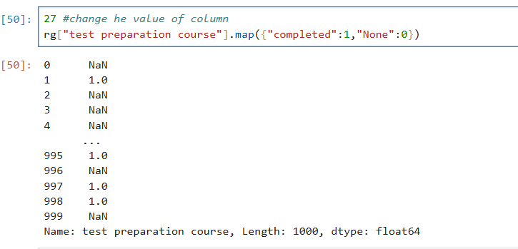

1. select the element in the first row and first column

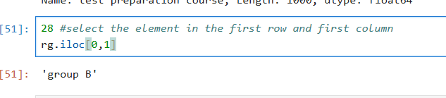

1. select the element in the specific row and first column

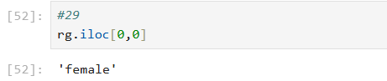

1. find all rows where gender is male and writing score is 60

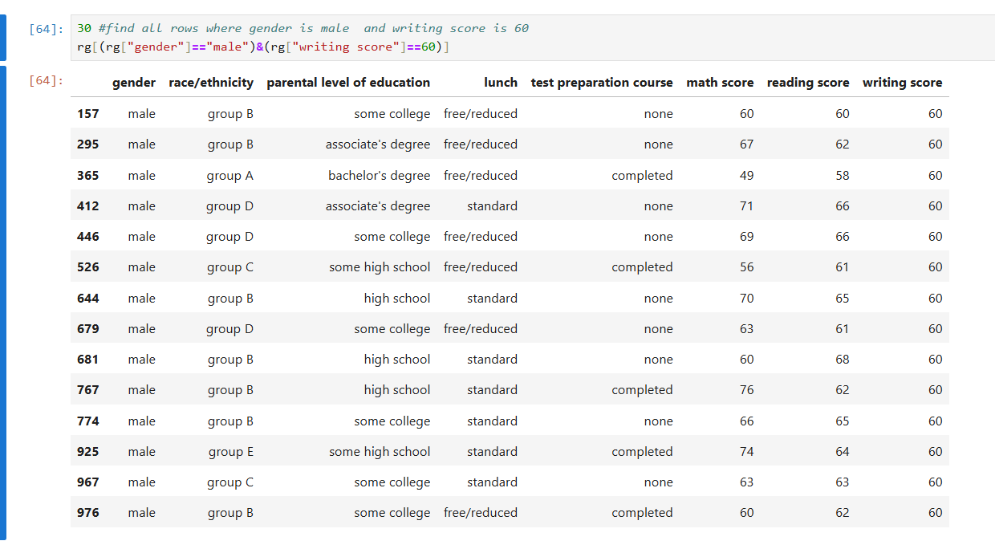

1. select the first thre rows of the writing and reading column

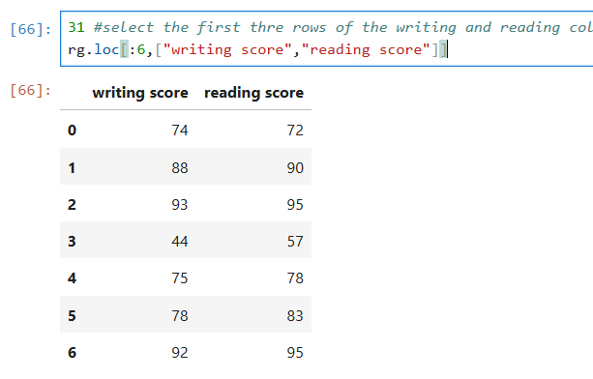

1. change the lunch for gender

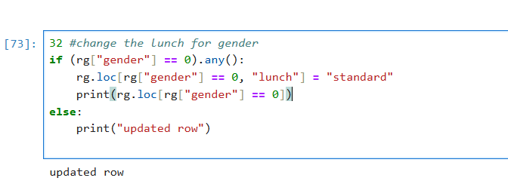

1. print the first and fifth row along with second column

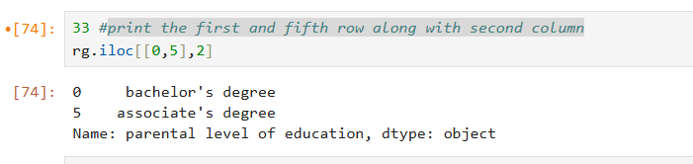

1. Show the 'gender' values for the rows at index 0 and 5

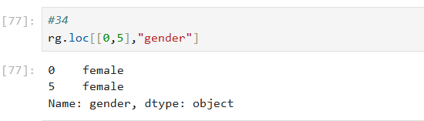

38 . Count and display the occurrences of each unique value in the 'parental level of education' column

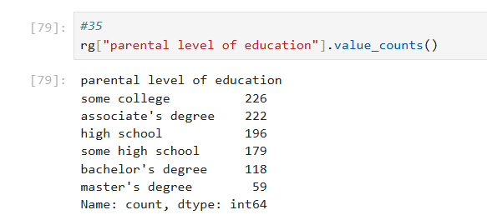

1. select twwo column named race/ethnicity and lunch start from index no1 and end on index no18 and skip at 2

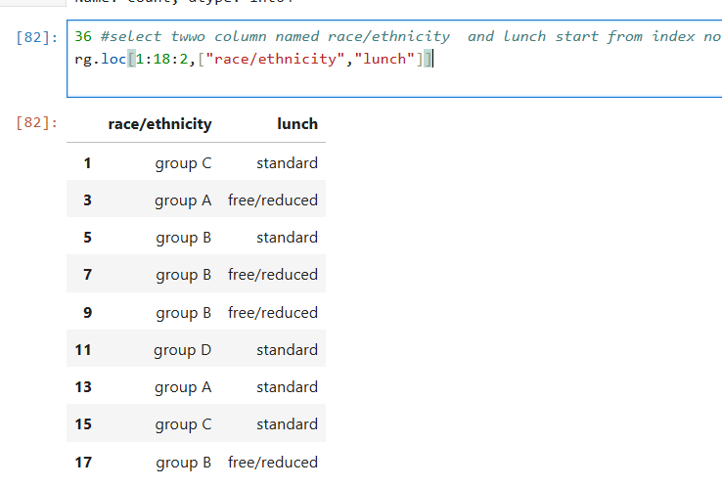

1. rangee of column

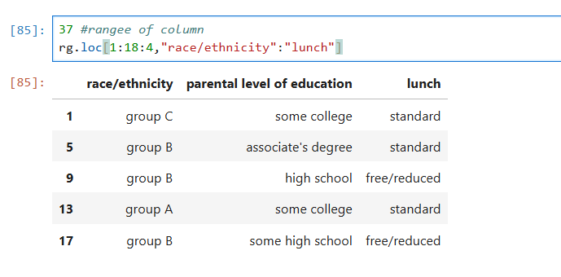

1. Show all data for male students and display the first five rows.

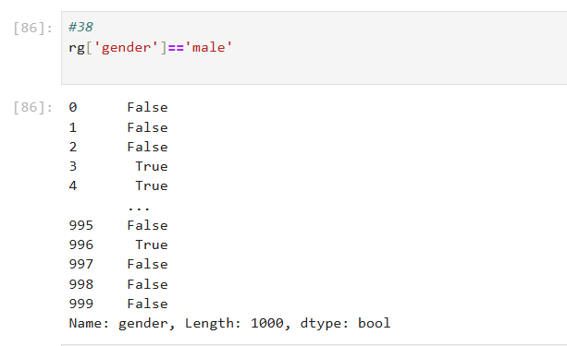

1. Show all data for male students and display the first five rows.

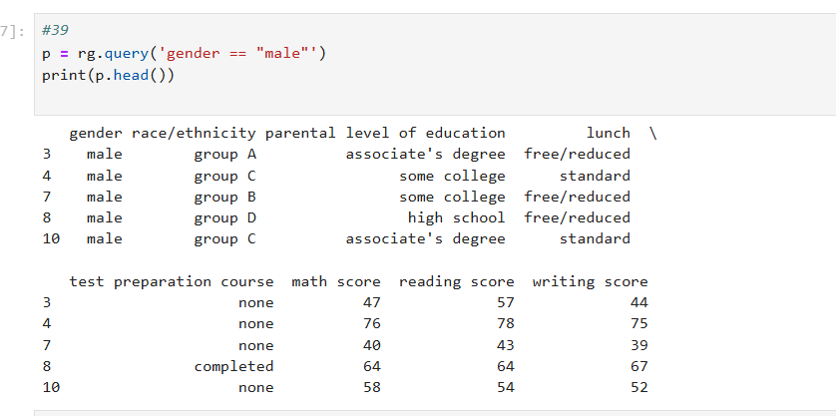

1. Show the math, reading, and writing scores along with gender for all male students and display the first five rows

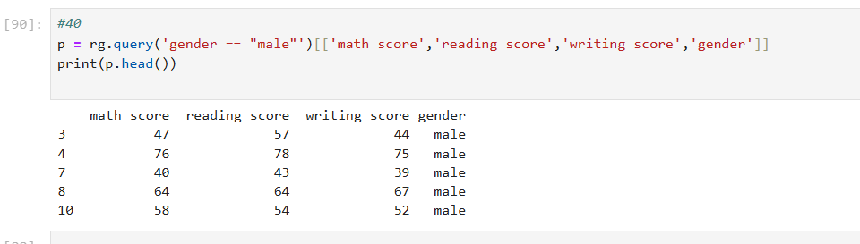

44."Show all values from the 'test preparation course' column where the data is either 'none' or 'completed'.

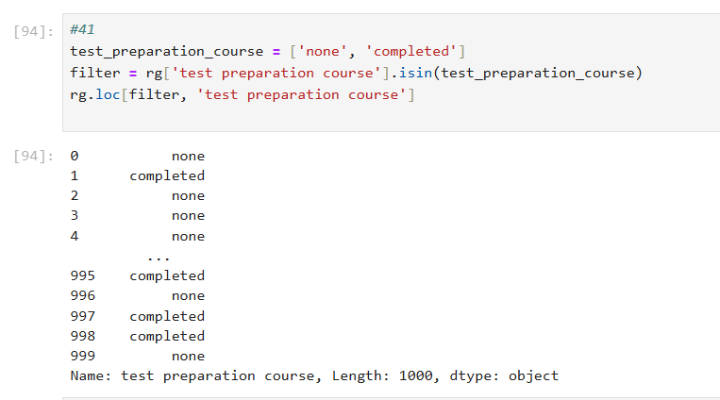

1. Show all values from the 'race/ethnicity' column where the data contains 'group A'.

